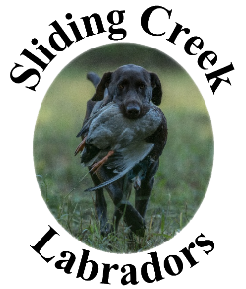
Terms of Sale and Guarantee

This contract is entered into by Sliding Creek Labradors (here and thereafter SCL) and the purchaser.

Sliding Creek Labradors
261 N McAllister Rd
Liberty, SC 29657
864-314-5326
www.slidingcreeklabs.com slidingcreeklabs@gmail.com

and

Name: _________________________________ and _________________________________

Address: _________________________________

_________________________________

Phone: _________________________________ Email: _________________________________

SCL agrees to sell the purchaser a Labrador Retriever puppy.

Whelped: _________________________________
Sire: _________________________________
Dam: _________________________________
Color: _________________________________Sex:______________
Microchip#: _________________________________

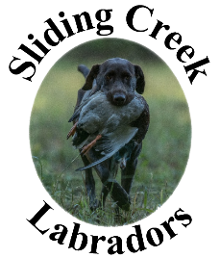
Warranty:

Puppies bred and whelped at SCL carry the following warranty. This covers genetic problems that would prevent this animal from hips being certified by the Orthopedic Foundation for Animals (OFA) and eyes receiving a normal rating by CERF. Furthermore the seller certifies that the puppy is in good health at the time of purchase.

We offer this warranty providing the purchaser complies with the following;

Seller warrants that the puppy is in good health at the time the Buyer assumes ownership. Buyer agrees to have the puppy examined by a licensed Veterinarian within one (1) week of receipt of puppy. If, as a result of the examination, the Veterinarian determines that the puppy is suffering from a serious medical condition, providing the examining veterinarian concludes to a substantial degree of medical certainty the condition arose while the animal was under the care of the Seller, the Seller may choose to either replace the puppy by one of equal value or refund the full purchase price. If the option is chosen to replace the puppy the Buyer shall immediately return the puppy at Buyer’s expense. Puppies eligible for replacement pursuant to the terms of this warranty must be returned to Seller along with a duly executed AKC and UKC document transferring entirely Buyer’s ownership in the puppy to the Seller. If the Buyer elects to keep the puppy the seller is NOT obligated to pay for any veterinary treatment.

In order for the eye guarantee to be honored, the dog must be examined by a CERF approved American College of Veterinary Ophthalmologists Diplomate within two months after the dog reaches 12 months of age. The Seller guarantees that the dog is free of inheritable, genetic eye defects that prevent it from functioning as a field retriever.

In order for the hip guarantee to be honored, the dog MUST be x-rayed AND certified within two months after the dog reaches 24 months of age. X-rays must be done by a BOARD CERTIFIED VETERINARIAN. Hips must be rejected by OFA in order to collect on this agreement.

If your pup’s hips are found to be dysplastic or fails CERF rating, SCL will replace it with a puppy of equal breeding. This will occur after the return of the pup and it’s papers which are to be transferred also. If the price of the pup chosen is greater than the original pup purchased, the purchaser will pay the difference. The expense of any veterinary charges, transporting the pup to be replaced to SCL, Liberty, SC, or transporting the replacement pup to the buyer will be assumed by the buyer.

In order for this guarantee to be honored, buyer must abide by the following;

- A copy of the findings from OFA or CERF MUST be sent to us for our records.
- THE DOG MUST NOT BE BRED.
- The dog must not have been transferred to a new owner.
- If you are returning the dog a copy of this guarantee must accompany the dog.
- The dog has not received any type of traumatic injuries or mistreatment.

OR, because we hope that this pup will become an important member of your family, it is not necessary to return the pup to collect on the agreement. Should you have a problem but what to keep your dog, we will, upon proof of dysplasia of failed CERF, refund one half of the original purchase price of the dog. The dog must be spayed/neutered at the buyers expense and proof of the same provided to us. The OFA shall be the sole judge regarding hip dysplasia.

It is understood that the above warranty is expressly regarding congenital, hereditary defects and any physical injury to the dog or defects resulting from lack of proper nourishment or neglect voids this guarantee. To ensure proper nourishment pups should be fed a high quality dog food.

Purchase Price of the Pup: __________________________ Dam: ___________________________
Microchip Number: __________________________ Sire: ___________________________
AKC Litter Registration # __________________________ Shots and Worming Record: see attached

_______________________________________________ __________________________________Signature Signature of Seller Signature of Buyer

Breeder: Sliding Creek Labradors - Celeste Nauman

